

|  |  |
| --- | --- |
|  |  |
|  | Description of collected Autolib database |
|  |  |
|  | DDI_Autolib description |
|  |  |

# Source and License

Data was extracted from opendataparis.com, where the Autolib availability information was available in real-time. The accessed database was the following:

* Name: Stations Autolib: Disponibilité en temps réel
* Producer : Autolib
* Date : see below
* License : Open Database License

Any further publication should include this mention and respect the terms of the Open Database License.

# Collected Data

This sample contains data from April 1 to April 9, 2018.

Overall, Dalberg Data Insights had collected data at the following times:

* First pilot: every 5 minutes from October 6, 2017, 11:13 AM to October 8, 2017, 10:21 AM
* Second Pilot: every minute from October 9, 2017, 15:53 PM to October 10, 2017, 15:31PM
* Production: every minute from October 30, 16:59 PM to July 31, 2018, 23:59 PM (date of the end of the Autolib services, although our automatic downloads went on after that).

During the collection periods, on some occasions the download failed, which created dome gaps in the data. These gaps are represented on Figures 1 and 2. Except for an important gap from November 11 to November 14, 2017, missing files were rare.

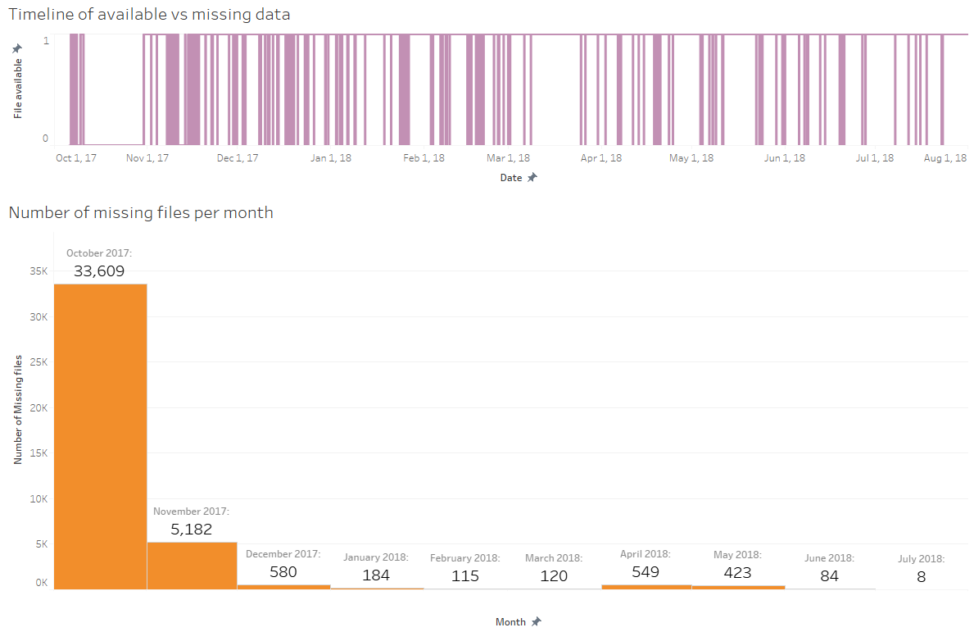

Figure 1: Autolib files availability over time

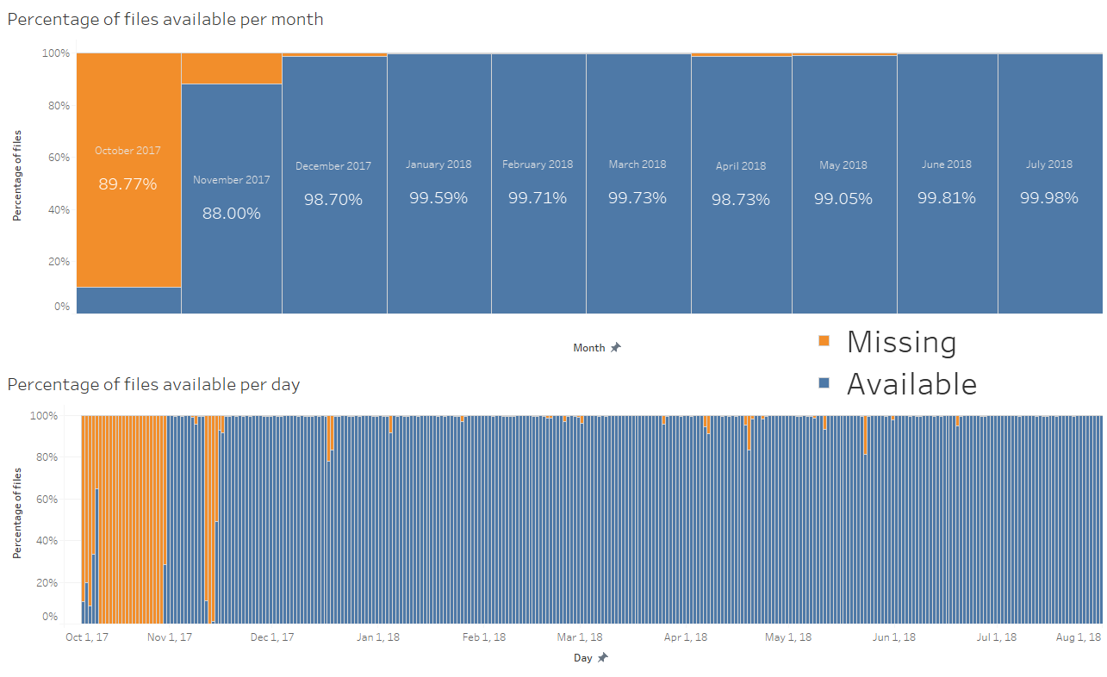

Figure 2: Percentage of available/missing files per month and per day

# Fields

The data contains the following fields:

* Address
* Cars
* Bluecar counter
* Utilib counter
* Utilib 1.4 counter
* Charge Slots
* Charging Status
* City
* Displayed comment
* ID
* Kind
* Geo point
* Postal code
* Public name
* Rental status
* Scheduled at
* Slots
* Station type
* Status
* Subscription status
* Year
* Month
* Day
* Hour
* minute

No official description of the field was published together with the data.

From discussions during the Citymakers project, web and data exploration, Dalberg Data Insights has built the following understanding of the different fields. These descriptions are the best of Dalberg Data Insights’s knowledge, but are provided without any guarantee (orange background indicate what we call “resources”):

|  |  |  |  |
| --- | --- | --- | --- |
| **Column name** | **Type** | **Values** | **Comments** |
| Address | String |  | address of the station |
| Cars | Number | [0-7] | Number of cars available at the station - redundant with Bluecar counter, always the same value |
| Bluecar counter | Number | [0-7] | Number of Bluecars available at the station |
| Utilib counter | Number | (0-4] | Number of Utilibs available at the station |
| Utilib 1.4 counter | Number | [0-5] | Number of Utilib 1.4 available at the station |
| Charge Slots | Number | [0-3] | Number of Charging slots available at the station |
| Charging Status | String | {"nonexistent","operational","broken","future", some typos} | Whether the station is operational for recharging. Mainly "nonexistent", "operational" or "broken": charge slots can only be greater than 0 when "operational"; slots and vehicles can be available in all situations (except future stations that have 0 resources) |
| City | String |  | City |
| Displayed comment | String |  | Some comments like "station within parking, access through …" |
| ID | String |  | ID of the station |
| Kind | String | {"STATION","SPACE,"PARKING",CENTER"} | "CENTER" have no resources at all; "PARKING" do not have charge slots, but can have bluecars and utilib; "STATION" and "SPACE" can have all resources |
| Geo point | String |  | GPS coordinates of the station |
| Postal code | Number |  | Postal code of the station |
| Public name | String |  | Name of the station |
| Rental status | String | {"nonexistent","operational","broken","future", a few empty} | Whether the station is available for renting vehicles. Resources are only available when "operational", except for "broken" which can have Slots, but none of the other resources (Bluecars, utilib or charging slots). |
| Scheduled at | String | datetime | Planned opening date: non empty values only for stations that have "future" in one of the statuses. |
| Slots | Number | [0-7] | Number of parking slots available at the station? |
| Station type | String | {"station","full_station","subs_center"} | No resources available for "subs_center" - which is just one location. Was that actually a selling point for Autolib subscriptions? |
| Status | String | {"ok","closed","scheduled"} | No resources available for "scheduled", which is the status if there is a "scheduled at" date. Yet there can be resources associated with "closed" stations |
| Subscription status | String | {"nonexistent","operational","broken","future"} | Whether it is possible to subscribe to the autolib service in that station? No resources available when "future", but other values can have resources |

For information, the attached Excel sheets also includes the number of occurrences in each category over a large period of time (November 2017 to June 2018):

